**Day7==accept data from user using input fields**

**firstName LastName age**

**store data in Object format in function**

**and convert into JSON format and display data in table format from JSON format data**

**Question 3: Accept user data → store in Object → convert to JSON → display in table**

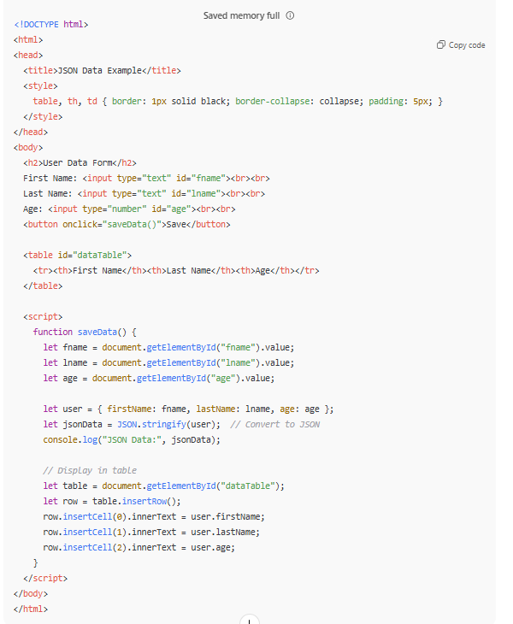

**Question 4: Create username dynamically**

👉 From same user data:  
Take **first 2 chars** from firstName + **last 2 chars** from lastName + **age**

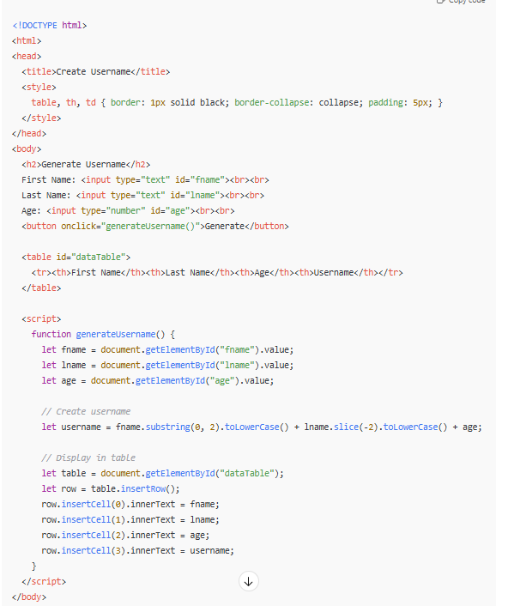

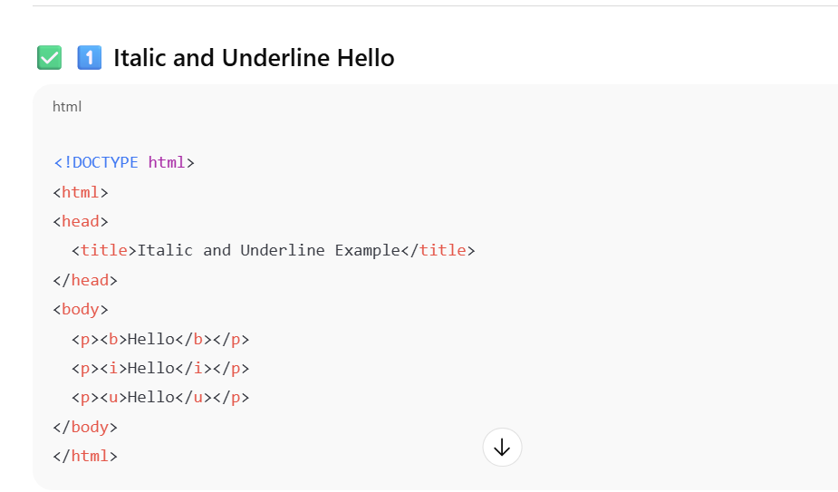

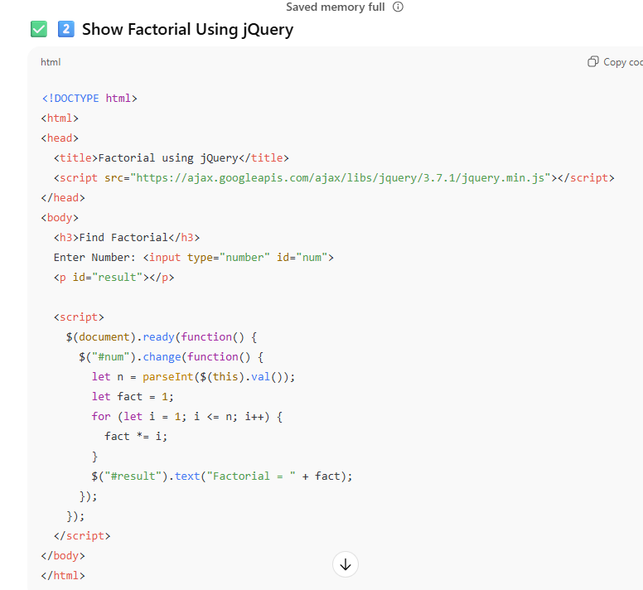

✅ **3️⃣ Display Multiplication Table Using jQuery**

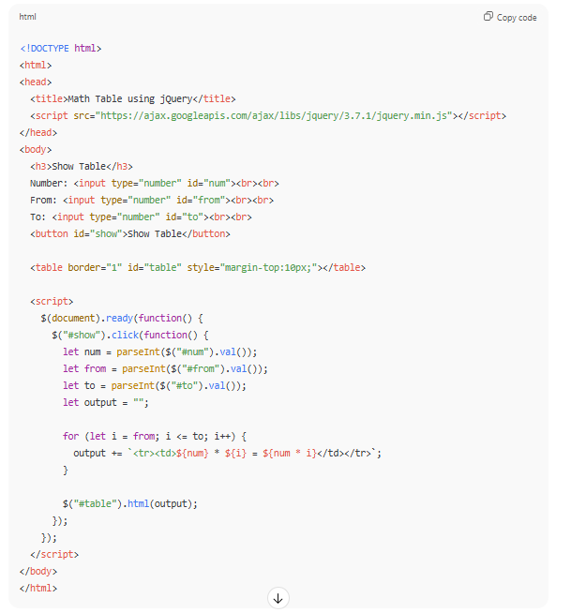

Fade in fadeout slide down slide up

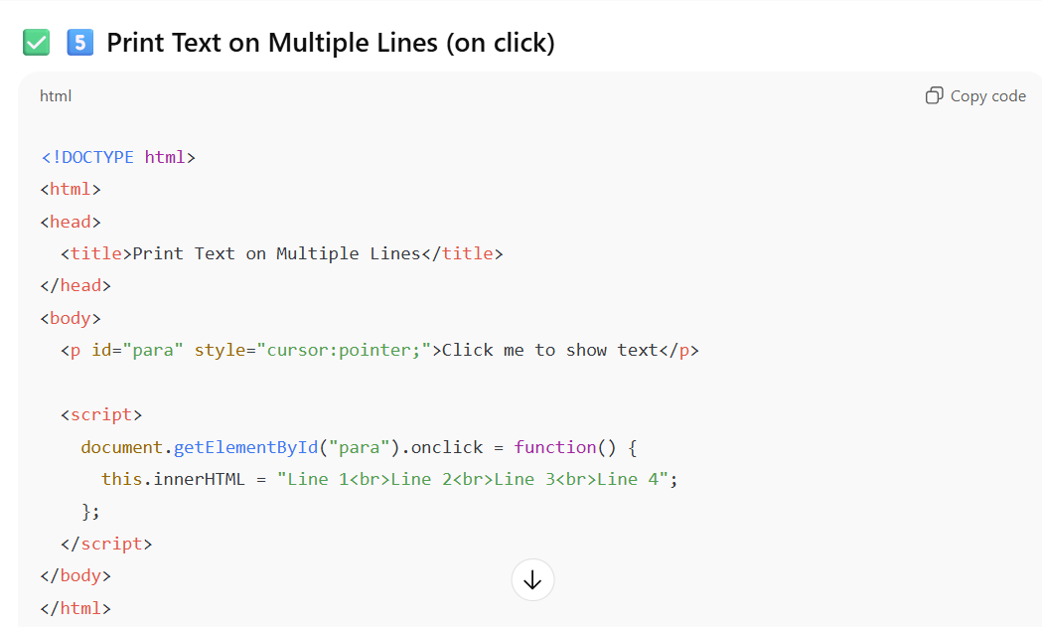

✅ **1️⃣ AJAX – Display Data from a Text File on Button Click**

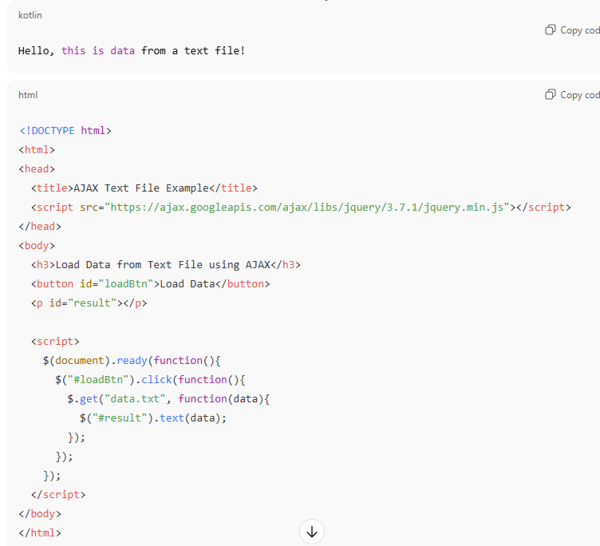

2️⃣ AJAX – Get Data from URL and Display in Table

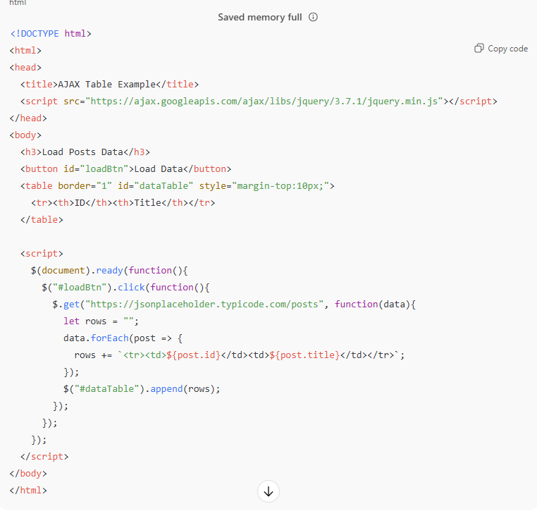

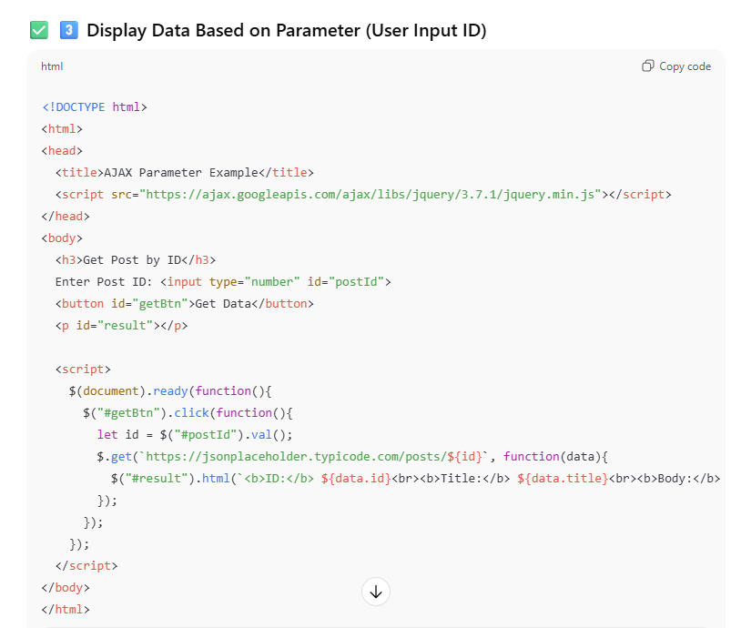

use HTML predefined Validations

required , minlength , maxlength

and display error message if data is not properly entered

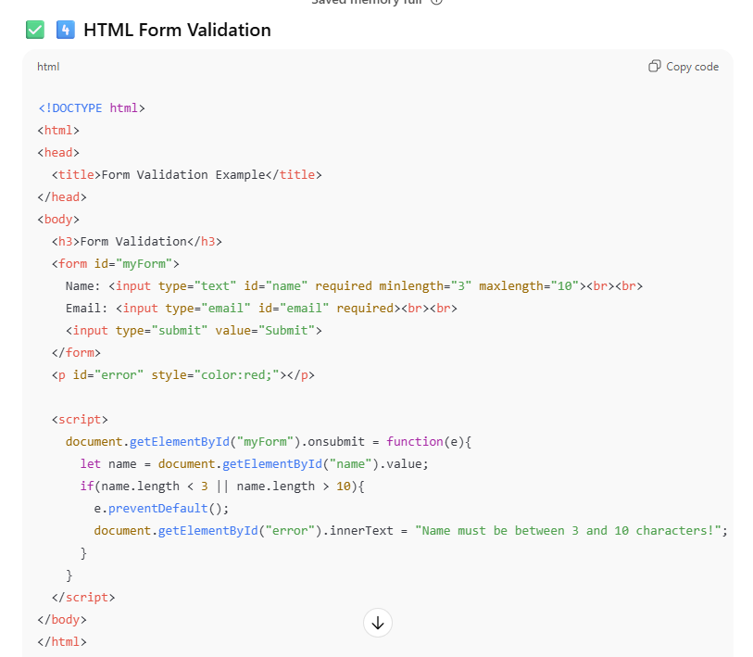

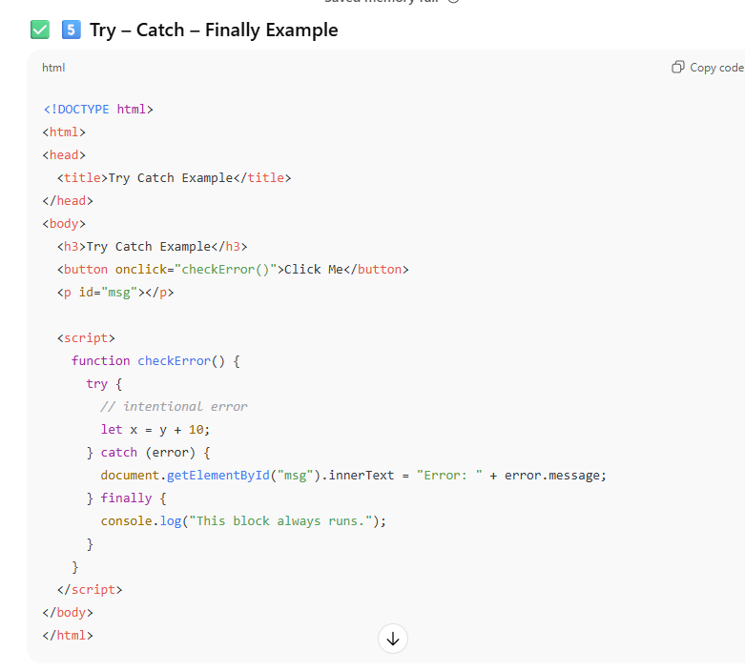

CSS Styling Using jQuery Methods

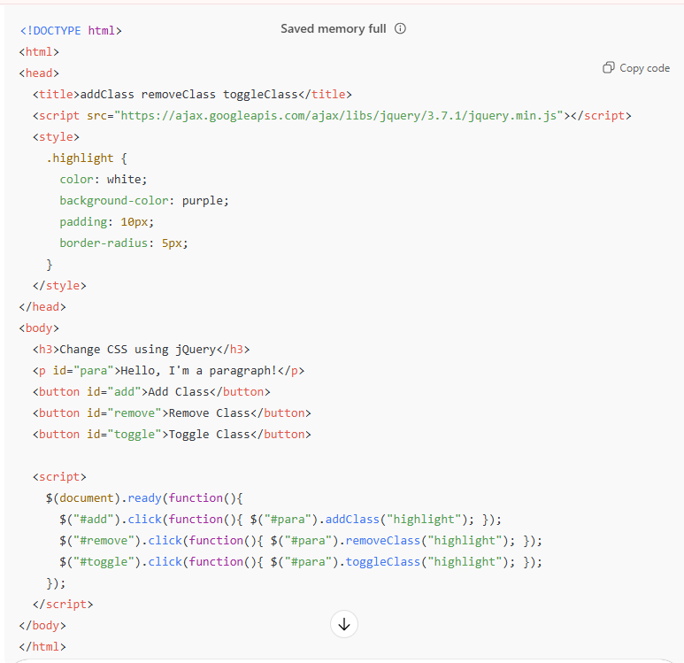

Calculator????????????

